Google Maps Page 1 of 1

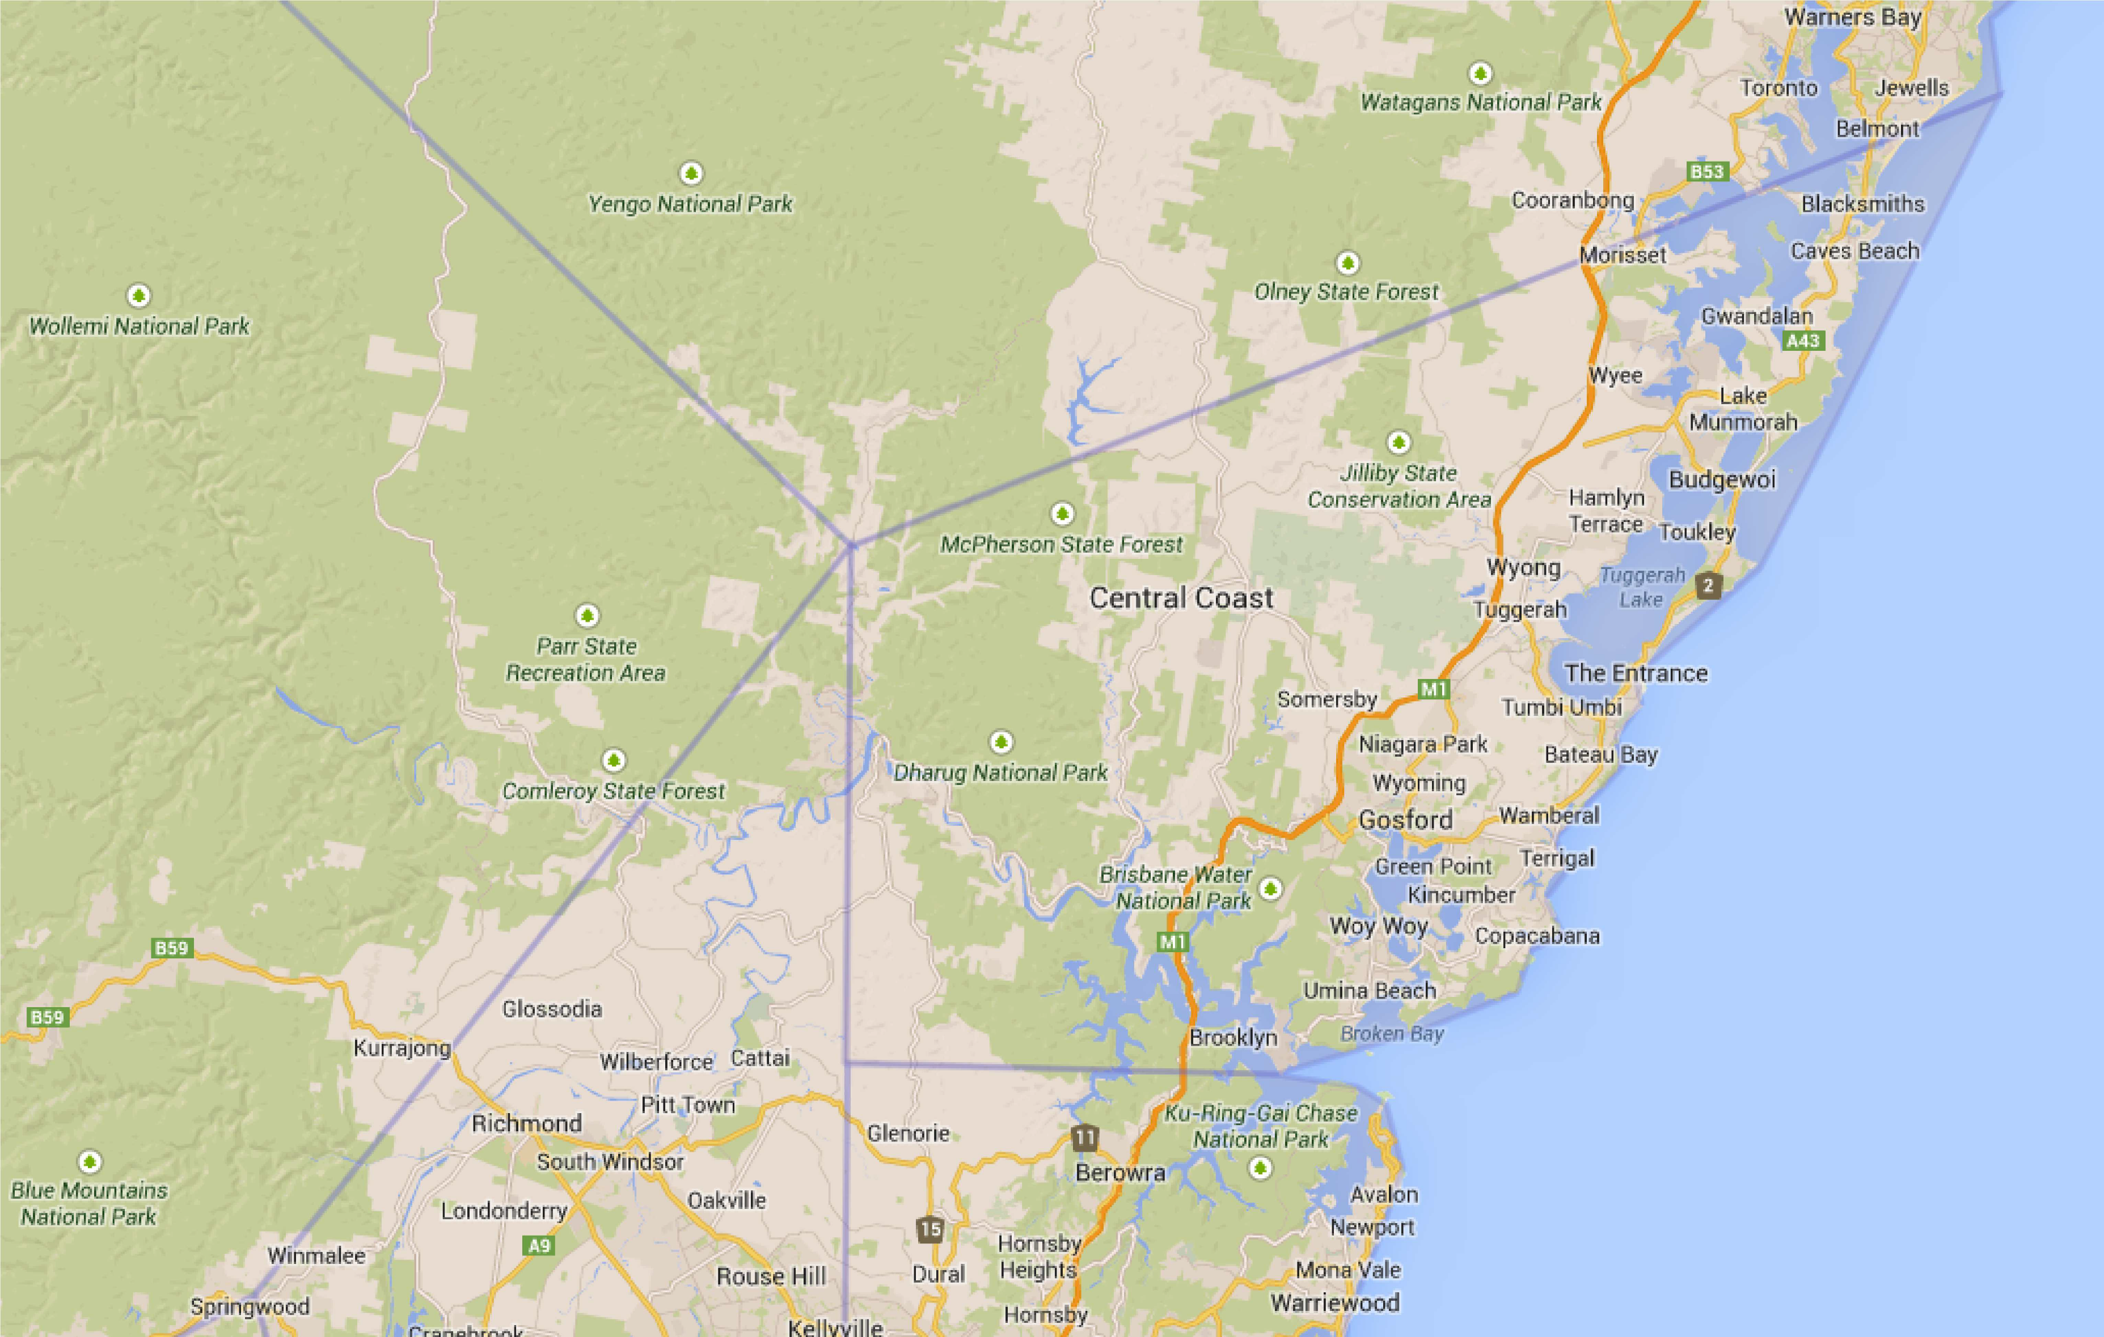Zone 5 Central Coast
CURRENT: Bateau Bay; Davistown RSL; Everglades; Gosford, Gwandalan; Halekulani; Munmorah, Ourimbah RSL; The Entrance; Terrigal; Toukley RSL; Umina; Wamberal; Woy Woy..

Map data ©2014 Google 10 km

https://www.google.com.au/maps/@-33.3411582,151.334105,10z/data=!4m2!6m1!4s217994262276212043533.0004f58bafdc5a0f5a201... 28/01/2017

